Link for Penpot project with links:

<https://design.penpot.app/#/view/5d8c4d0a-1e64-8116-8002-7386c0d5eaa0?page-id=5d8c4d0a-1e64-8116-8002-7386c0d5eaa1&section=interactions&index=0&share-id=248140e0-d822-80a6-8002-73a62a8de5ee>

Link for wireframe 2:

<https://design.penpot.app/#/view/248140e0-d822-80a6-8002-738042c6d5da?page-id=0656f724-90d3-81c2-8002-6bedb01dc75e&section=interactions&index=0&share-id=5d8c4d0a-1e64-8116-8002-73a86c92b894>

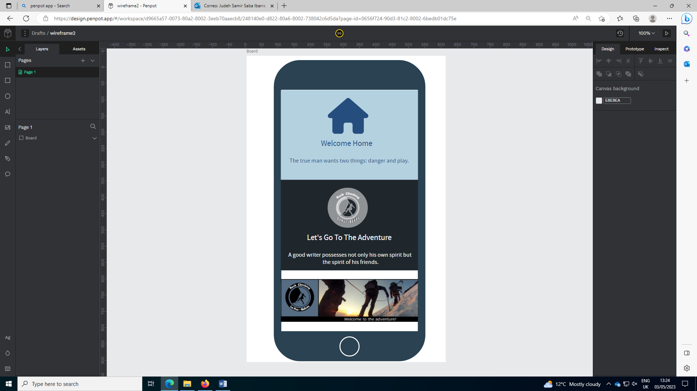

Link for wireframe 1:

<https://design.penpot.app/#/view/0656f724-90d3-81c2-8002-6bedb01dc75d?page-id=0656f724-90d3-81c2-8002-6bedb01dc75e&section=interactions&index=0&share-id=248140e0-d822-80a6-8002-73a8fc62333f>

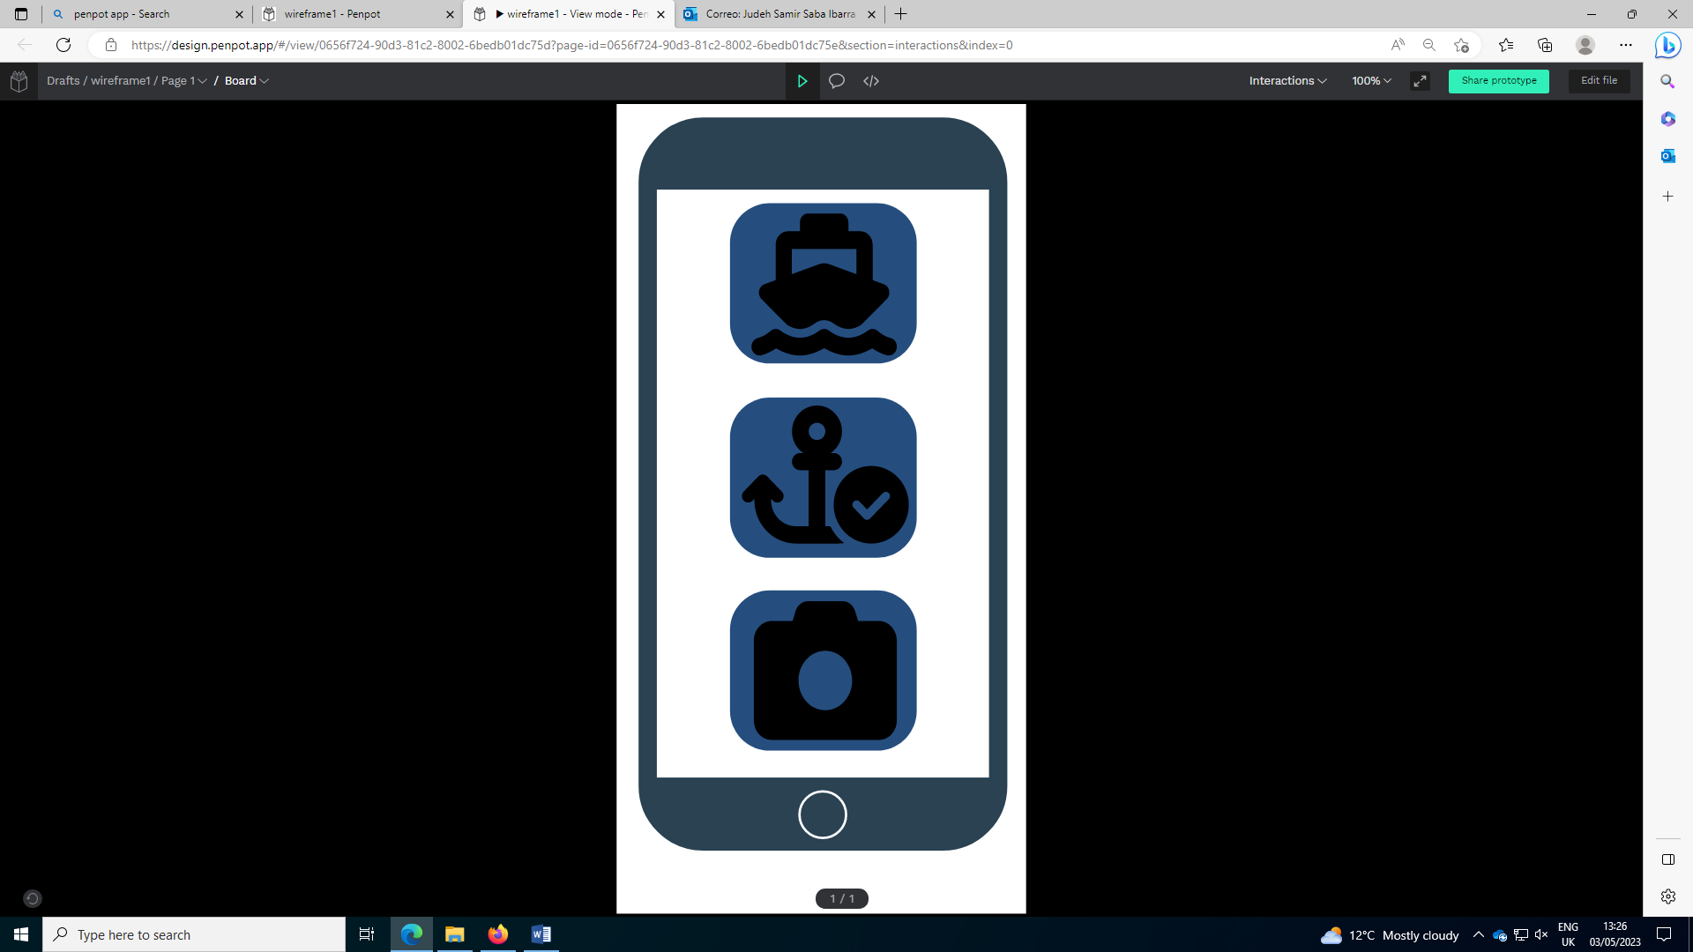

Link for the planning prototype on penpot:

<https://design.penpot.app/#/view/cdbb0844-1a10-813c-8002-6bede4eab7b4?page-id=d5fc0283-ef1c-80fa-8002-3eec28110f70&section=interactions&index=0&share-id=248140e0-d822-80a6-8002-73a93217f081>

